in##Chapter 1

Computers and Algorithms

Problem-solving using computers requires good command of computers, programming and the programming language that will be used for writing programs. The objective of this material is to provide the essentials of writing computer programs. Even though the focus will be on writing programs in the C++ language; the same concepts can be applied to writing programs in any other programming language such as C, C#, PHP, Java and Python.

1.1 Basic Concepts

Digital computers have become a very powerful tool for problem-solving nowadays. The computer is an electronic device that is capable of carrying out arithmetic and logical operations at a very high speed. In addition, it can store a huge amount of data. To use the computer in problem-solving one should know the elements of the computer system. These elements are categorized as Hardware and Software. Hardware is the physical parts of the computer such as the Central Processing Unit (CPU), Disk Drives, Keyboard, Memory, and Monitor. The software is the programs that make users benefit from the hardware. A program is a set of instructions, written in a formal way, to have the computer solve a problem by performing a specific task. The computer cannot think, so it depends on the human mind to supply it with the necessary instructions to solve a problem. The set of steps required to solve a problem is called an algorithm. Algorithms should be converted to programs using a programming language such as C++ in order to be executed by computer.

1.2 Computer Hardware

A personal computer is a computing machine that consists of a number of electronic components that work together in order to achieve some useful mission (such as controlling bank accounts or even helping in writing a letter). Each component has a very specific job. All the components of a computer are mounted on/connected to a large board (called the motherboard) as shown in figure 1.1.

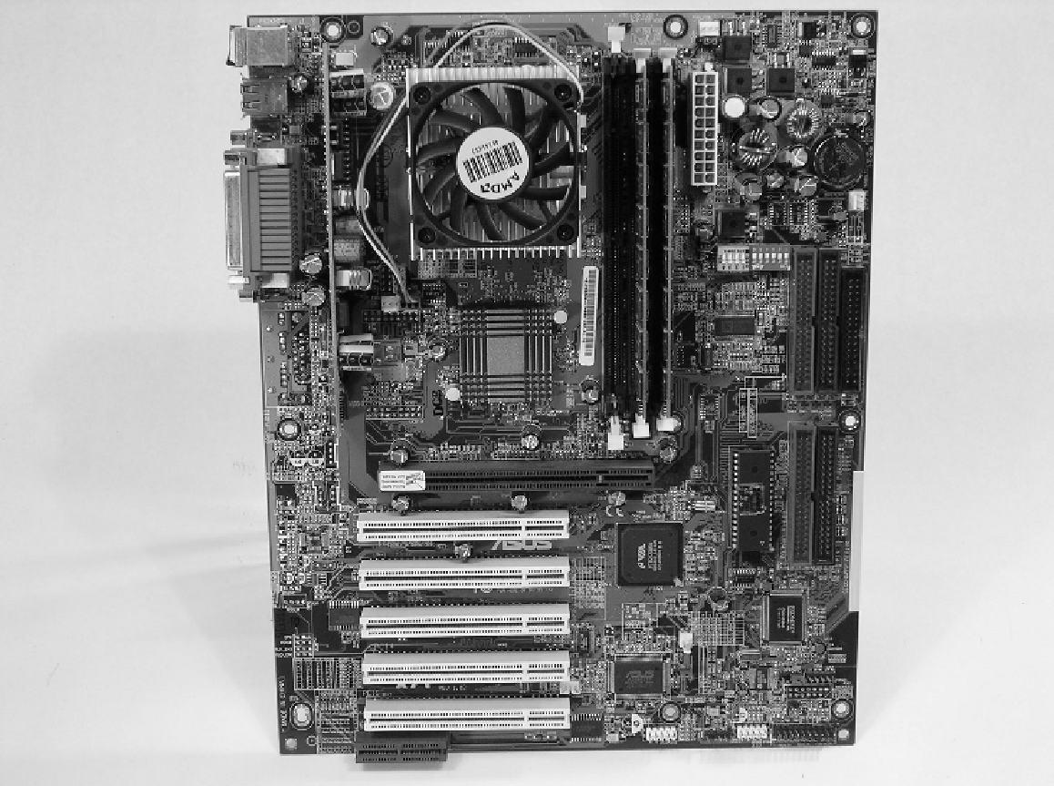

Fig. 1.1 The motherboard

The computer components need electric power to operate. The part in a computer that provides this power is the power supply. A power supply takes 110-volt or 220-volt alternating current (AC) from the wall outlet and converts it into the direct current (DC) voltage levels that the computer needs to operate. Power supplies are rated in watts. A watt is a unit of power. The higher the number, the more power the computer will be able to use. Most computers use power supplies in the 250 to 400 watt range. Both the power supply and the motherboard are enclosed inside the computer’s case as shown in figure 1.2.
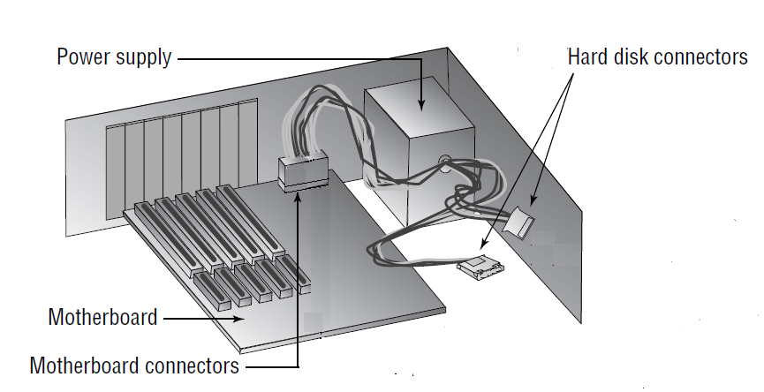

Fig. 1.2 The power supply and motherboard enclosed inside the computer case
The basic hardware components of a computer include CPU (also called the microprocessor or simply the Processor), Primary Storage, Secondary Storage, Input Device, and Output Device. Each of these components has a role in the computer system and they have a highly controlled interaction to accomplish specific tasks. For example, to run a program, stored in the secondary storage, it must be loaded to the primary storage. The data to be processed maybe entered using the keyboard. CPU processes the data and the result is displayed on the output device. Figure 1.3 shows the way these components interact, with the arrows indicating the direction of data flow.

Fig. 1.3 Components of a Computer

Secondary
Storage

Output Device

Input Device

Main Storage

CPU

CPU plays two roles: it coordinates all the computer operations and performs arithmetic and logical operations on data. It is the brain and workhorse of the computer. To carry out its work, CPU follows the instructions of the program under execution. In fact, the individual operations provided by CPU are very simple but they are performed at a very high speed (more than million operations per second).

The computer has two kinds of main memory, the Read Only Memory (ROM) and the Random Access Memory (RAM). ROM contains the Basic Input/output System (BIOS). It is a collection of programs permanently stored in the computer to perform some basic functions. These functions include the control of the keyboard, monitor, disk drives, and serial communications. Also, the system ROM enables the computer to start the operating system (boot). In addition, the ROM contains the Power-On Self Test (POST) program that checks the main components of the computer and generates an error message or a beep code if any component is malfunctioning. As these programs are vital to the computer to work, they are stored on a chip as part of the computer hardware. The BIOS configuration settings such as date & time, number of hard disks, boot sequence and so on are stored in a special kind of memory called CMOS (Complementary Metal Oxide Semiconductor). CMOS memory is powered by a small battery so the settings are retained when the computer is shut off.

On the other hand, RAM (also known as the primary storage) is used for storing the running programs, the currently used data, and some other memory resident system programs. It consists of a number of storage cells (memory locations) called Bytes. A byte consists of 8 smaller units called bits (binary digits); one bit can represent either the value 0 or the value 1. This is known as the binary representation of data. According to this representation, each byte can store either one character or a value in the range 0 to 255 or -128 to 127. The number system that uses the 0’s and 1’s is called the binary number system; it will be discussed in section 1.3.

The size of RAM is the number of bytes it contains. The bytes in RAM are numbered from 0 to one less than the size of RAM. For example, if the size of memory is 1000 bytes; they will be numbered from 0 to 999. The number associated with a byte is called its address. So, each byte in RAM has a unique numerical address through which it can be referenced. The byte is the smallest addressable piece of RAM. The amount of RAM is limited and it loses all the stored data when the computer is switched off. So, it is unsuitable for storing large amounts of data or permanently storing even a small amount of data. For these reasons computers are equipped with secondary storage devices.

Secondary storage devices include Magnetic Tapes, Floppy Disks, Hard Disks, CD-ROM’s, CD R/W, DVD/s and USB Flash Drives. The main advantages of these devices are the high storage capacity, portability, and the permanent storing of information and programs. But the main disadvantage is the low data transfer rate.

The computer interacts with the outside world through the input and output devices. The input devices are used to transfer the programs to be executed and the data to be processed to the computer RAM. The main input devices are the keyboard, scanner and microphone. The output devices receive the results from the computer RAM and make it visible to and/or usable by the user. The familiar output devices are the monitor, printer and speaker. Also, there are some devices categorized as input/output (I/O) devices as they serve the two purposes. The Hard Disk, Floppy Disk, CD R/W and the USB Flash Drive are typical examples.

1.3 Decimal and Binary Number Systems

The purpose of a number system is to represent the different numeric values. Each number system uses a set of valid digits and weighted position notation (i.e. each position in which a digit is written has a different positional weight). The number of valid digits of a number system is called the base of the system. The base is directly related to the positional weight. In this section an overview of both the decimal (used by humans) and the binary (used by computers) number systems will be introduced.
The decimal number system is the most commonly used number system (to the best of the author’s knowledge it is used by everyone everywhere in the world). So, when an integer such as 227, 101, or 163 is used it is assumed, by default, to be a decimal number. The decimal number system has 10 digits, which are 0, 1, 2, 3, 4, 5, 6, 7, 8 and 9. Hence, the base of this number system is 10.

The positional weights of the decimal number system are calculated from right to left starting with 1 (i.e. the rightmost position has the weight 1) and multiplied by 10 (the base) from right to left. For example, in the decimal number 234 (the 2, the 3 and the 4 are referred to as symbol values), it is said that the 4 is written in the ones position, the 3 is written in the tens position and the 2 is written in the hundreds position.

So, 234 = 10x10x1 x 2 + 10x1 x 3 + 1 x 4.

It also can be noted that each of these positions is a power of the base (base 10) and that these powers begin at 0 and increase by 1 from right to left in the number.

So, 234 = 10² x 2 + 10¹ x 3 + 10⁰ x 4.

For longer decimal numbers, the next positions to the left would be the thousands position (10 to the 3rd power), the ten-thousand position (10 to the 4th power) and so on.

As electronic devices, computers use voltage levels to represent data. A bit may have one of two voltage levels. One of these levels represents the value 0 and the other represents the value 1. This means that, internally, computers use a number system that consists of only 2 digits (0 & 1). Therefore, it is called the binary number system and its base is 2.

Similar to the decimal number system, the positional weights of the binary number system are calculated from right to left starting with 1 (i.e. the rightmost position has the weight 1) and multiplied by 2 (the base) from right to left. For example, in the binary number 101, the rightmost 1 is written in the ones position, the 0 is written in the twos position and the leftmost 1 is written in the fours position.

So, 101 = 2x2x1 x 1 + 2x1 x 0 + 1 x 1 = 5.

It also can be noted that each of these positions is a power of the base (base 2) and that these powers begin at 0 and increase by 1 from right to left in the number.

So, 101 = 2² x 1 + 2¹ x 0 + 2⁰ x 1
= 4 + 0 + 1 = 5.

For longer binary numbers, the next positions to the left would be the eights position
(2 to the 3rd power), the sixteens position (2 to the 4th power), the thirty-twos position (2 to the 5th power), the sixty-fours position (2 to the 6th power) and so on.

Converting from Binary to Decimal
The decimal numbers are the most commonly used, therefore it is often convenient to convert a binary number to decimal to get a sense of the “real” value of the number. To convert a number from binary to decimal, multiply the value of each digit by its positional value and sum these products. For example, the binary number 110101 is converted to decimal 53 as shown in the following table.

Positional values: | 32 | 16 | 8 | 4 | 2 | 1
Symbol values: | 1 | 1 | 0 | 1 | 0 | 1
Products: | 32 | 16 | 0 | 4 | 0 | 1

Sum = 32 + 16 + 0 + 4 + 0 + 1 = 53

Converting from Decimal to Binary
The conversions in the previous example naturally follow the positional notation conventions. Also, converting from decimal to binary follows these conventions. The following are the steps of converting a decimal number to its binary equivalent.

- Scan the binary system’s positional values right to left until reaching the last column whose positional value is less than or equal to the decimal number to be converted.

- Write 1 in this column.

- Subtract this positional value from the number to be converted and get the remainder.

- Repeat steps 1, 2 & 3 with the remaining positional values using the remainder as the value to be converted until the remainder is 0.

- Write 0’s in the columns that are not filled with 1’s.

Suppose it is required to convert the decimal 45 to binary. Begin by writing the positional values of the columns right to left until reaching the last column whose positional value is less than or equal to the decimal number to be converted (45). Thus, write:

Positional values: 32 16 8 4 2 1

Notice that the 64 is ignored because it is greater than the number to be converted (45).
Write 1 in the leftmost column (32).

Positional values: | 32 | 16 | 8 | 4 | 2 | 1
Symbol values: | 1

Subtract 32 from 45 and get the remainder (13). In the remaining columns, find the last column whose positional value is less than or equal to the remainder (13). Write 1 in this column (8).

Positional values: | 32 | 16 | 8 | 4 | 2 | 1
Symbol values: | 1 |  | 1

Subtract 8 from 13 and get the remainder (5). In the remaining columns, find the last column whose positional value is less than or equal to the remainder (5). Write 1 in this column (4).

Positional values: | 32 | 16 | 8 | 4 | 2 | 1
Symbol values: | 1 |  | 1 | 1

Subtract 4 from 5 and get the remainder (1). In the remaining columns, find the last column whose positional value is less than or equal to the remainder (1). Write 1 in this column (1).

Positional values: | 32 | 16 | 8 | 4 | 2 | 1
Symbol values: | 1 |  | 1 | 1 |  | 1

Subtract 1 from 1 and get the remainder (0). At this point, no more searches are required; write 0’s in the columns that are not filled with 1’s. This gives:

Positional values: | 32 | 16 | 8 | 4 | 2 | 1
Symbol values: | 1 | 0 | 1 | 1 | 0 | 1

And thus the decimal 45 is equivalent to the binary 101101.

1.4 Computer Software

As a matter of fact, the computer hardware by itself is less beneficial and difficult to deal with. It requires some facilities to make humans able to exploit it. These facilities are called the computer software. They are sophisticated computer programs, written by professionals, to make programmers as well as ordinary users do their work on the computer. Computer software can be categorized to two main categories: System Software and Application Software. The two major components of the system software are Operating Systems (OS’s) and Language Translators.
OS is a collection of programs that serve two main purposes. The first, they control and facilitates the interaction of the user and the computer hardware. The latter, they manage the hardware resources such as CPU, RAM, Secondary Storage, and the Input and Output Devices. The following are examples of OS’s: DOS, UNIX, LINUX, and Windows (7, 8 & 10). Loading OS into the computer memory is called the booting process.

Language Translators, as their name implies, are used to translate programs written in a High-Level Language (HLL) such as C, C++ and Visual BASIC into a Low-Level Language (LLL) [also called machine language] that can be understood by the machine. Each programming language has its own translator. Language Translators can be divided into two main classes: Interpreters and Compilers in addition to Assemblers. The difference between interpreters and compilers is that interpreters translate and execute a program one instruction at a time. On the other hand, compilers translate the entire program into machine language prior to starting execution. Assemblers are used to translate from Assembly Language to machine language. Assembly Language falls into a mid-way between an HLL and machine language.

The programs that are written to help a computer user in carrying out his/her work are called Application Software. For example, word processors such as Microsoft Word and WordPerfect are used for dealing with documents. While a spreadsheet program such as Microsoft Excel helps in performing calculations and generating charts. The computer users who want to prepare presentations may use application programs such as Microsoft PowerPoint. The user who is going to use application software must make sure that it is compatible with his/her hardware and OS.

1.5 Problem-solving

Problem-solving means the design of a set of steps, which when applied to some available data (Input) produce a specific result (Output). This set of steps is called the algorithm. To have the problem solved by computer the algorithm must be converted into a program in a suitable programming language such as C++. A graphical representation of the problem-solving process is shown in figure 1.4.

Input Output

Fig. 1.4 Problem Solving Process

Algorithm
(Program)

The process of problem-solving by computer includes the following five steps: problem definition, writing an algorithm/drawing a flowchart, tracing the algorithm, converting the algorithm into a computer program and testing the program. The first three steps will be explained starting the following subsection and the last two steps will be tackled starting chapter 2.

1.5.1 Problem Definition

Problem definition is the first step in the problem-solving process. It is clearly and precisely defining what is required to be done, the output variables and the input variables.

When a programmer is going to write an algorithm he/she has to represent the familiar concepts of the problem such as salary, students’ grades, phone numbers, etc. as variables of particular names and types. The variable name is used to reference the variable in the algorithm and its type identifies the legal operations to be performed using that variable. The variables are either numeric or alphanumeric. Numeric variables hold numbers; they can be used in arithmetic operations, read, printed (written), and compared. Alphanumeric variables hold characters such as names, addresses, and student grades; they can be read, printed and compared. The outcome of this phase is the problem variables; they are listed in what is called a Data Table.

The Data Table is a declaration for all the variables to be used in the algorithm. A variable is declared by specifying its category, name, and role. Variables are categorized as Output Variables, Input Variables, Input/output Variables and Program Variables (will be discussed in the following subsection).

- Output Variables are the variables that hold the solution of the problem.

- Input Variables are the variables whose values are/should be available either from the problem phrasing or by giving them their values at the execution time (reading them). A variable is read if its value is not given in the problem or changes from one execution of the algorithm to another.

- Input/Output Variables are the variables that hold values to the program as input and hold different values at the end of the program as output.

The role of a variable is a brief description of what it is used for in the algorithm.

1.5.2 Developing the Algorithm

After developing the data table of the algorithm, the programmer has to resolve the solution of the problem into steps. At this phase the programmer may need to introduce some intermediate variables that help in solving the problem in question. These variables are categorized as “Program Variables.”

- Program Variables are the variables used by the programmer to help him/her in solving the problem but they are neither input nor output. These variables must be declared in the Data Table.

Developing the algorithm should be performed with the following points in mind:

- An algorithm does what we “tell” it to do not what we “want” it to do.

- The steps of an algorithm are processed in order.

- Each step must perform only one operation.

- Each variable must be declared in the Data Table.

- Each variable must be given a value (initialized) before being printed (written) or used in calculations. A variable is given a value by either an assignment (replacement) step or a "Read" step.

- A variable is given its value by a “Read” step if its value is not given in the problem.

- A variable is given its value by an assignment step if its initial value is given in the problem or its method of calculation is known.

- Program variables are given values by replacement step.

- An algorithm has one and only one start point, and one and only one end point.

- An algorithm should be finite, i.e. there must be no possibility that it could continue forever without reaching a solution.

- Starting at the start point should lead to the end point under any condition.

In order to trace the algorithm it must be represented on paper. An algorithm may be presented in either a written form or a Program Flowchart form.

Written algorithm (pseudo code): An algorithm may be represented as a sequence of ordered steps with/without serial numbers. These ordered steps may be written in ordinary English or any other language. This method has two main advantages. The first is its flexibility as the programmer can express all his/her thoughts as he/she is writing in a natural language. The latter is that a well-written algorithm can be easily converted to a computer program. On the other hand, the main disadvantage is that it is a little bit difficult to trace because there is no standard way for writing it.

Program Flowchart: The other method of representing an algorithm is the Program Flowchart, which is a graphical representation of the algorithm using some standard shapes. The main advantages of using the Program Flowchart method are that it is straightforward, easy to trace, and suitable for beginners. In addition, using standard shapes makes it easy to be understood. But the major drawbacks of this method are that it is difficult to convert it to a program especially when a language such as C++ is used and loop statements (will be explained in chapter 4) look similar in the flowchart representation. The symbols used to draw a Program Flowchart are shown in figure 1.5.

Read
or
Write

Start/End

Process

Decision

Connector

Module
Call

Flow
Directions

Fig. 1.5 Symbols of Program Flowchart

1.5.3 Tracing the Algorithm

After the algorithm has been developed, its correctness should be tested. This can be done by applying the steps of the algorithm to different sets of input data with the output of each set is known. If the output of the algorithm is as expected this means that it may be correct. If this is not the case, even with one set, the algorithm should be revised.

Example 1.1

Write an algorithm and draw a flowchart to add two numbers and print the result.

The output of this problem is the sum of two numbers; let it be “Sum” The input of this problem should be two numbers; let us call them “Num1” and “Num2.” As the values of both “Num1” and “Num2” are not given in the problem; they will be given using a read step. A read step means that the value(s) will be entered at runtime. Although the value of “Sum” is not given in the problem, it will be given its value using an assignment (replacement) step because its method of calculation is known.

Data Table
Start

Output Variable
Read
Num1, Num2

Av: The average of the two numbers.

Input Variables
Sum = Num1+Num2

Num1: The 1st number to be used.
Num2: The 2nd number to be used.
Write
Sum

Program Variable

Sum: The sum of the two numbers
End

Algorithm: Written form

Read Num1, Num2
Sum = Num1 + Num2 Fig 1.6 Flowchart of Example 1.1
Write Sum
End

Example 1.2

Write an algorithm and draw a flowchart to calculate and print the average of two numbers.

The output of this problem is the average of two numbers; let it be “Av.” The input of this problem should be two numbers; let us call them “Num1” and “Num2.” But, it is known that the average is calculated by dividing the sum of the two numbers by 2. So, a new variable to hold the sum of the two numbers may be introduced. Let this new variable be called “Sum.” The variable “Sum” is neither an input variable nor an output variable; but it is used to help in calculating the average; so it is categorized as a program variable.

Data Table
Start

Output Variable
Read
Num1, Num2

Av: The average of the two numbers.

Input Variables
Sum = Num1+Num2

Num1: The 1st number to be used.
Num2: The 2nd number to be used.
Av = Sum/2

Program Variable

Sum: The sum of the two numbers
Write
Av

Algorithm: Written form

Read Num1, Num2
End

Sum = Num1 + Num2
Av = Sum/2
Write Av
End Fig 1.7 Flowchart of Example 1.2

Example 1.3

Write an algorithm and draw a flowchart to compute the time and cost of an auto-trip using the following formulas:

(1) Time = Distance / Speed.

(2) Gallons of gas used = Distance / kms per gallon.

(3) Cost of the trip = Gallons used X Cost per gallon.

Provided that the cost per gallon is L.E 160.

Data Table

Output Variables

Time: Time of the trip
Cost: Cost of the trip

Start

Read
Kpg

Read
Dist, Speed

Time = Dist/ Speed

Galused = Dist/Kpg

Cost = Galused *Cpg

Write
Time, Cost

Cpg = 160

End

Fig. 1.8 Flowchart of Example 1.3

Input Variables

Dist: Distance of the trip
Speed: Speed of the car
Kpg: Consumption rate in Kilometers per gallon
Cpg: Cost per gallon

Program Variable

Galused: gallons of gas used.

Algorithm: Written form

Read Dist, Speed
Time = Dist/Speed
Cpg = 160
Read Kpg
Galused = Dist/Kpg
Cost = Galused * Cpg
Write Time, Cost
End

Example 1.4

Write an algorithm and draw a flowchart to read the basic salary and the overtime hours of an employee and compute the employee's net salary as follows:

Net salary = Gross salary - Taxes
Gross salary = Basic salary + Payment from overtime
Taxes = Basic salary X Tax rate

Provided that the rate of overtime is L.E 35 / hour and the tax rate is 10%.

Start

End

Write
Net

Read
Basic, Ovh

Net = Gross - Taxes

Gross = Basic + Ovh * Pph

Taxr = 0.1

Pph = 35

Taxes = Basic * Taxr

Data Table

Output Variables

Net: Net salary

Input Variables

Basic: Basic salary
Ovh: Overtime hours
Taxr: Tax rate
Pph: Payment per hour

Program Variable

Gross: Gross salary
Taxes: Taxes

Algorithm: Written form

Read Basic, Ovh
Taxr = 0.1
Taxes = Basic * Taxr
Pph = 35
Gross = Basic + Ovh * Pph
Net = Gross - Taxes
Write Net
End

Fig. 1.9 Flowchart of Example 1.4
1.6 Features of Programming Languages

There are many programming languages that can be used to convert an algorithm to a computer program. As a matter of fact, all these languages possess similar facilities to enable programmers to:

- Give names to variables and possibly constants.

- Associate variables with types.

- Assign values to variables.

- Read data from input files or keyboard and send output to monitor, printer, or output file.

- Perform calculations such as multiplication, division, addition, and subtraction.

- Perform comparisons.

In addition, there are always facilities to raise a number to a power, find the square root of a value, and to apply trigonometric functions and so on.

Problems

1.1 Write an algorithm and draw a flowchart to calculate and print the sum and average of three numbers.

1.2 Write an algorithm and draw a flowchart to read the price of a sweater, a jeans and a shirt and print the amount to be paid for 2 sweaters, a jeans and 3 shirts.

1.3 Write an algorithm and draw a flowchart to convert a time slot in hours, minutes, and seconds into seconds.

1.4 Write an algorithm and draw a flowchart to convert a temperature in degrees Centigrade C and print the corresponding equivalent on the Fahrenheit scale F using the following formula:

F = C x 9/5 + 32

1.5 Write an algorithm and draw a flowchart to calculate the area of a field in feddan given its width and length in meters using the following formulas:

(1) Field area in m² = Length X Width

(2) Field area in feddan = Field area in m² / Square meters in feddan

Provided that 1 feddan = 4200 square meters.

1.6 Write an algorithm and draw a flowchart to calculate the volume of a cylinder given its radius and height using the following formula:

Volume = 3.14 x radius ² x height.

1.7 A farmer has a field B meters wide, L meters long. The field yields C cubic meters grain per feddan (1 feddan = 4200 square meters). The farmer has a number of cylindrical grain silos (containers), R meters in radius, H meters in height in which he stores the harvest. Write an algorithm and draw a flowchart that calculates and prints the number of used silos using the following formulas:

(1) Number of used silos = Total harvest/ Volume of silo

(2) Total harvest = Field area in feddan X Yield per feddan.

1.8 At the beginning of a journey the reading on a car’s odometer is S kilometers and the fuel tank is full. After the journey, the reading is F kilometers and it takes L liters to fill the tank. Write an algorithm and draw a flowchart to calculate and print the rate of fuel consumption in Km/liter.

1.9 A magnetic tape is L meters long, 1024 bytes/cm recording density and R cm/sec reading speed. Write an algorithm and draw a flowchart that outputs:

- The number of records that can be stored on the tape when the size of record is 512 bytes.

- The time taken to read the entire tape.

